Experiment No. 7
Aim: Simulate Si PN junction for various structural ( equilibrium , forward bias , reverse bias ) and environmental conditions and comment on the results obtained.
Software Tool: Technology Computer aided Design lab (TCAD) on nanohub.org
Theory:
Introduction to TCAD Simulation
The existing semiconductor industry is now fundamentally built on the assumption that almost every aspect of a chip is first designed in software.
Process simulation provides the ability to optimize and control the various processing steps, such as implantation, oxidation, diffusion, etching, and deposition, among others.
Device simulation either takes in-process simulation data or assumes certain device geometries, doping profiles, etc. and simulates electrical device performances. PADRE and Schred are tools of choice on nanoHUB.org for this simulation step. PADRE is a full-fledged simulation environment for semiclassical device simulation. It has a complicated input language that may be inappropriate for usage in those classroom environments where simple device modeling concepts need to be introduced. PN junction Lab, MOSCAP, and MOSFET are simplified GUI-driven tools.
PN Junction Lab - This tool enables users to explore and teach the basic concepts of P-N junction devices. Edit the doping concentrations, change the materials, tweak minority carrier lifetimes, and modify the ambient temperature. Then, see the effects in the energy band diagram, carrier densities, net charge distribution, I/V characteristic, etc.
Problem Statement 1:
A pn-diode has N_{A}=N_{D}=10¹⁶ cm⁻³ doping and a length of 1 um of both p and n-regions. Calculate analytically and verify via simulations the values of the:
(a) Built-in voltage V_{bi}
(b) Total depletion region width W.
(c) Maximum electrical field at the metallurgical junction.
Question1: What is the analytical value of the built-in potential and total depletion region width?

Question2: What is the extracted simulated value of the built-in potential and total depletion region width

Question3: What is the analytical value of the peak electric field?

Question4: What is the extracted simulated value of the peak electric field?

PN Junction I/O GUI
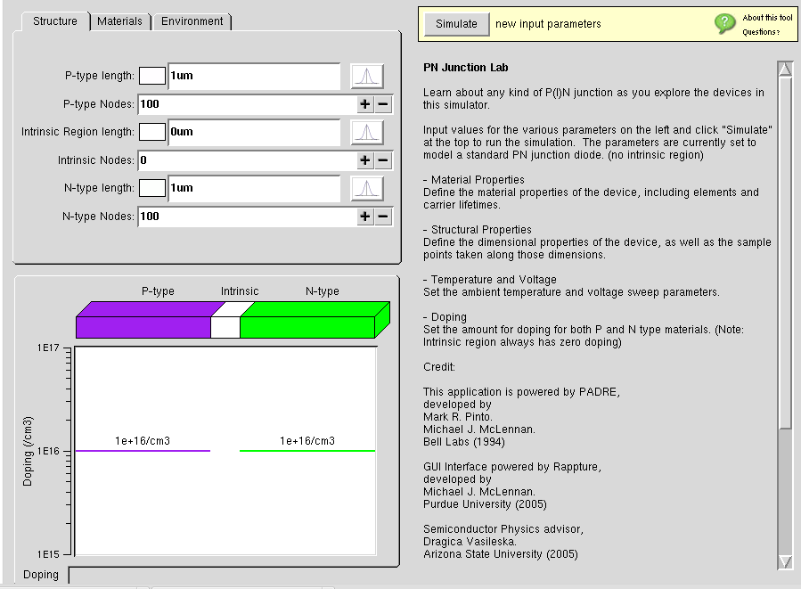
Problem Statement 2:
A pn-diode has N_{A}=N_{D}=10¹⁶ cm⁻³ doping and a length of 1 um of both p and n-regions. Calculate analytically and verify via simulations the values of the:
Simulate:
(a) Energy band profile under applied bias V_{A}= 0.6 V and V_{A} = -5 V
(b) quasi-Fermi level variation with position
(c) electric field under bias
(d) forward IV-characteristic of the diode

Question1: Comment on the electric field value variation and depletion region widths variation for a) Equilibrium case b) forward bias case and c) reverse bias cas
Question2 : How does the current vary with increasing the doping density of either the p- or n-region, or both?

Question 3 : In forward bias conditions, in the EBD where is the variation of the quasi-Fermi levels significant?

Simulation Result
Observe the following on the simulation :
- Energy Band diagram (at equilibrium) and (at applied bias)
- Net Charge Density (at equilibrium) and (at applied bias)
- Electrostatic potential (at equilibrium) and (at applied bias)
- Electric Field (at equilibrium) and (at applied bias)
- I-V Characteristics at applied forward and reverse bias
- Vary Doping from N_{A}=N_{D}=10¹⁶ cm⁻³ to N_{A}=N_{D}=10¹⁷ cm⁻³ , and compare I-V curve for both in forward bias conditions.
- Vary ambient temperature from 300k to 400k and compare I-V curve for both in forward bias conditions.

1a. EBD ( at equilibrium )

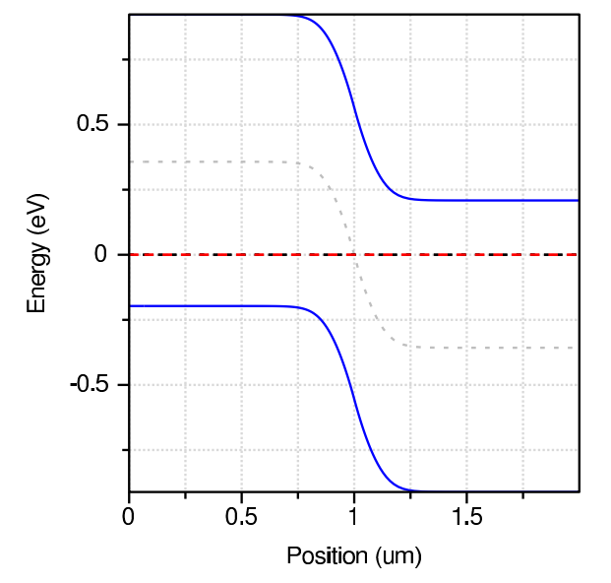

Conclusion:

